Task 3:
Array Sum Problem ( for array size 100,000,000 )
Sequential |  |  | 1 thread |  | 2 threads |  |  | 3 threads |  | 4 threads
Matrix Multiplication Problem ( for matrix size 1,000 )
Sequential |  |  | 1 thread |  | 2 threads |  |  | 3 threads |  | 4 threads
 | 

Task 4:
In an interesting turn of events the sequential program was faster than the parallel program with 1-4 threads when computing the Array Sum Problem. I wasn’t expecting this and redid the times and sure enough it held.
The Maxtrix Multplication had opposite results, with the sequential program running slower then my parralel. With each added thread, the time to compute was reduced significantly.

Screenshots of Code working as expected:
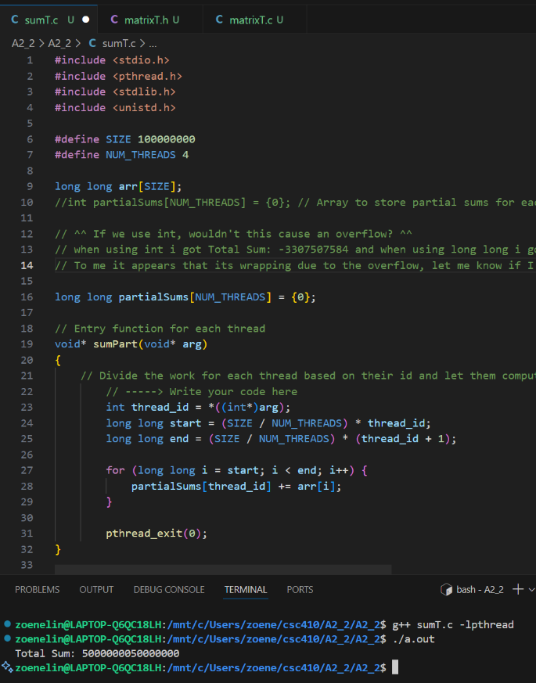
Coding task 1 screenshot

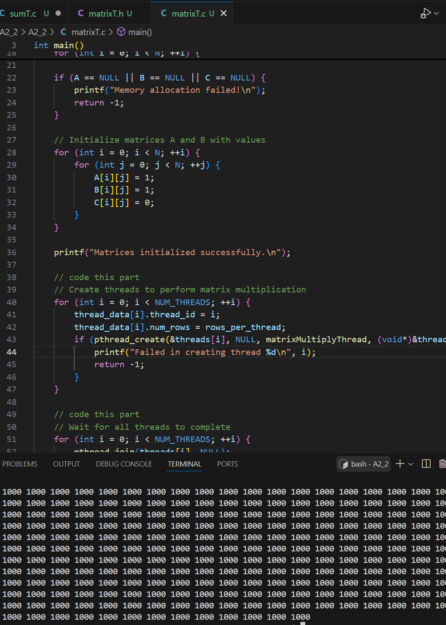
Coding task 2 screenshot

